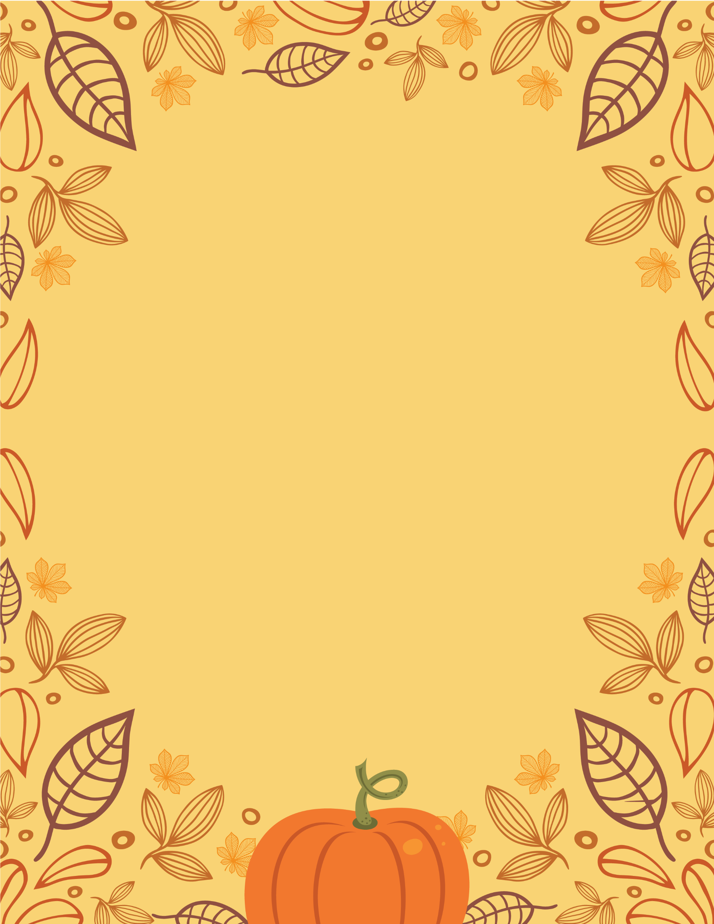
Join us for:

AUTUMN HARVEST
  - CELEBRATION
Saturday 27th September 2pm
Endon Village Hall
Hymns, readings, singing
Led By Rev Debbie & Rev Denise
Refreshments,
Donated produce Auction
Auctioneer Mark Simcock

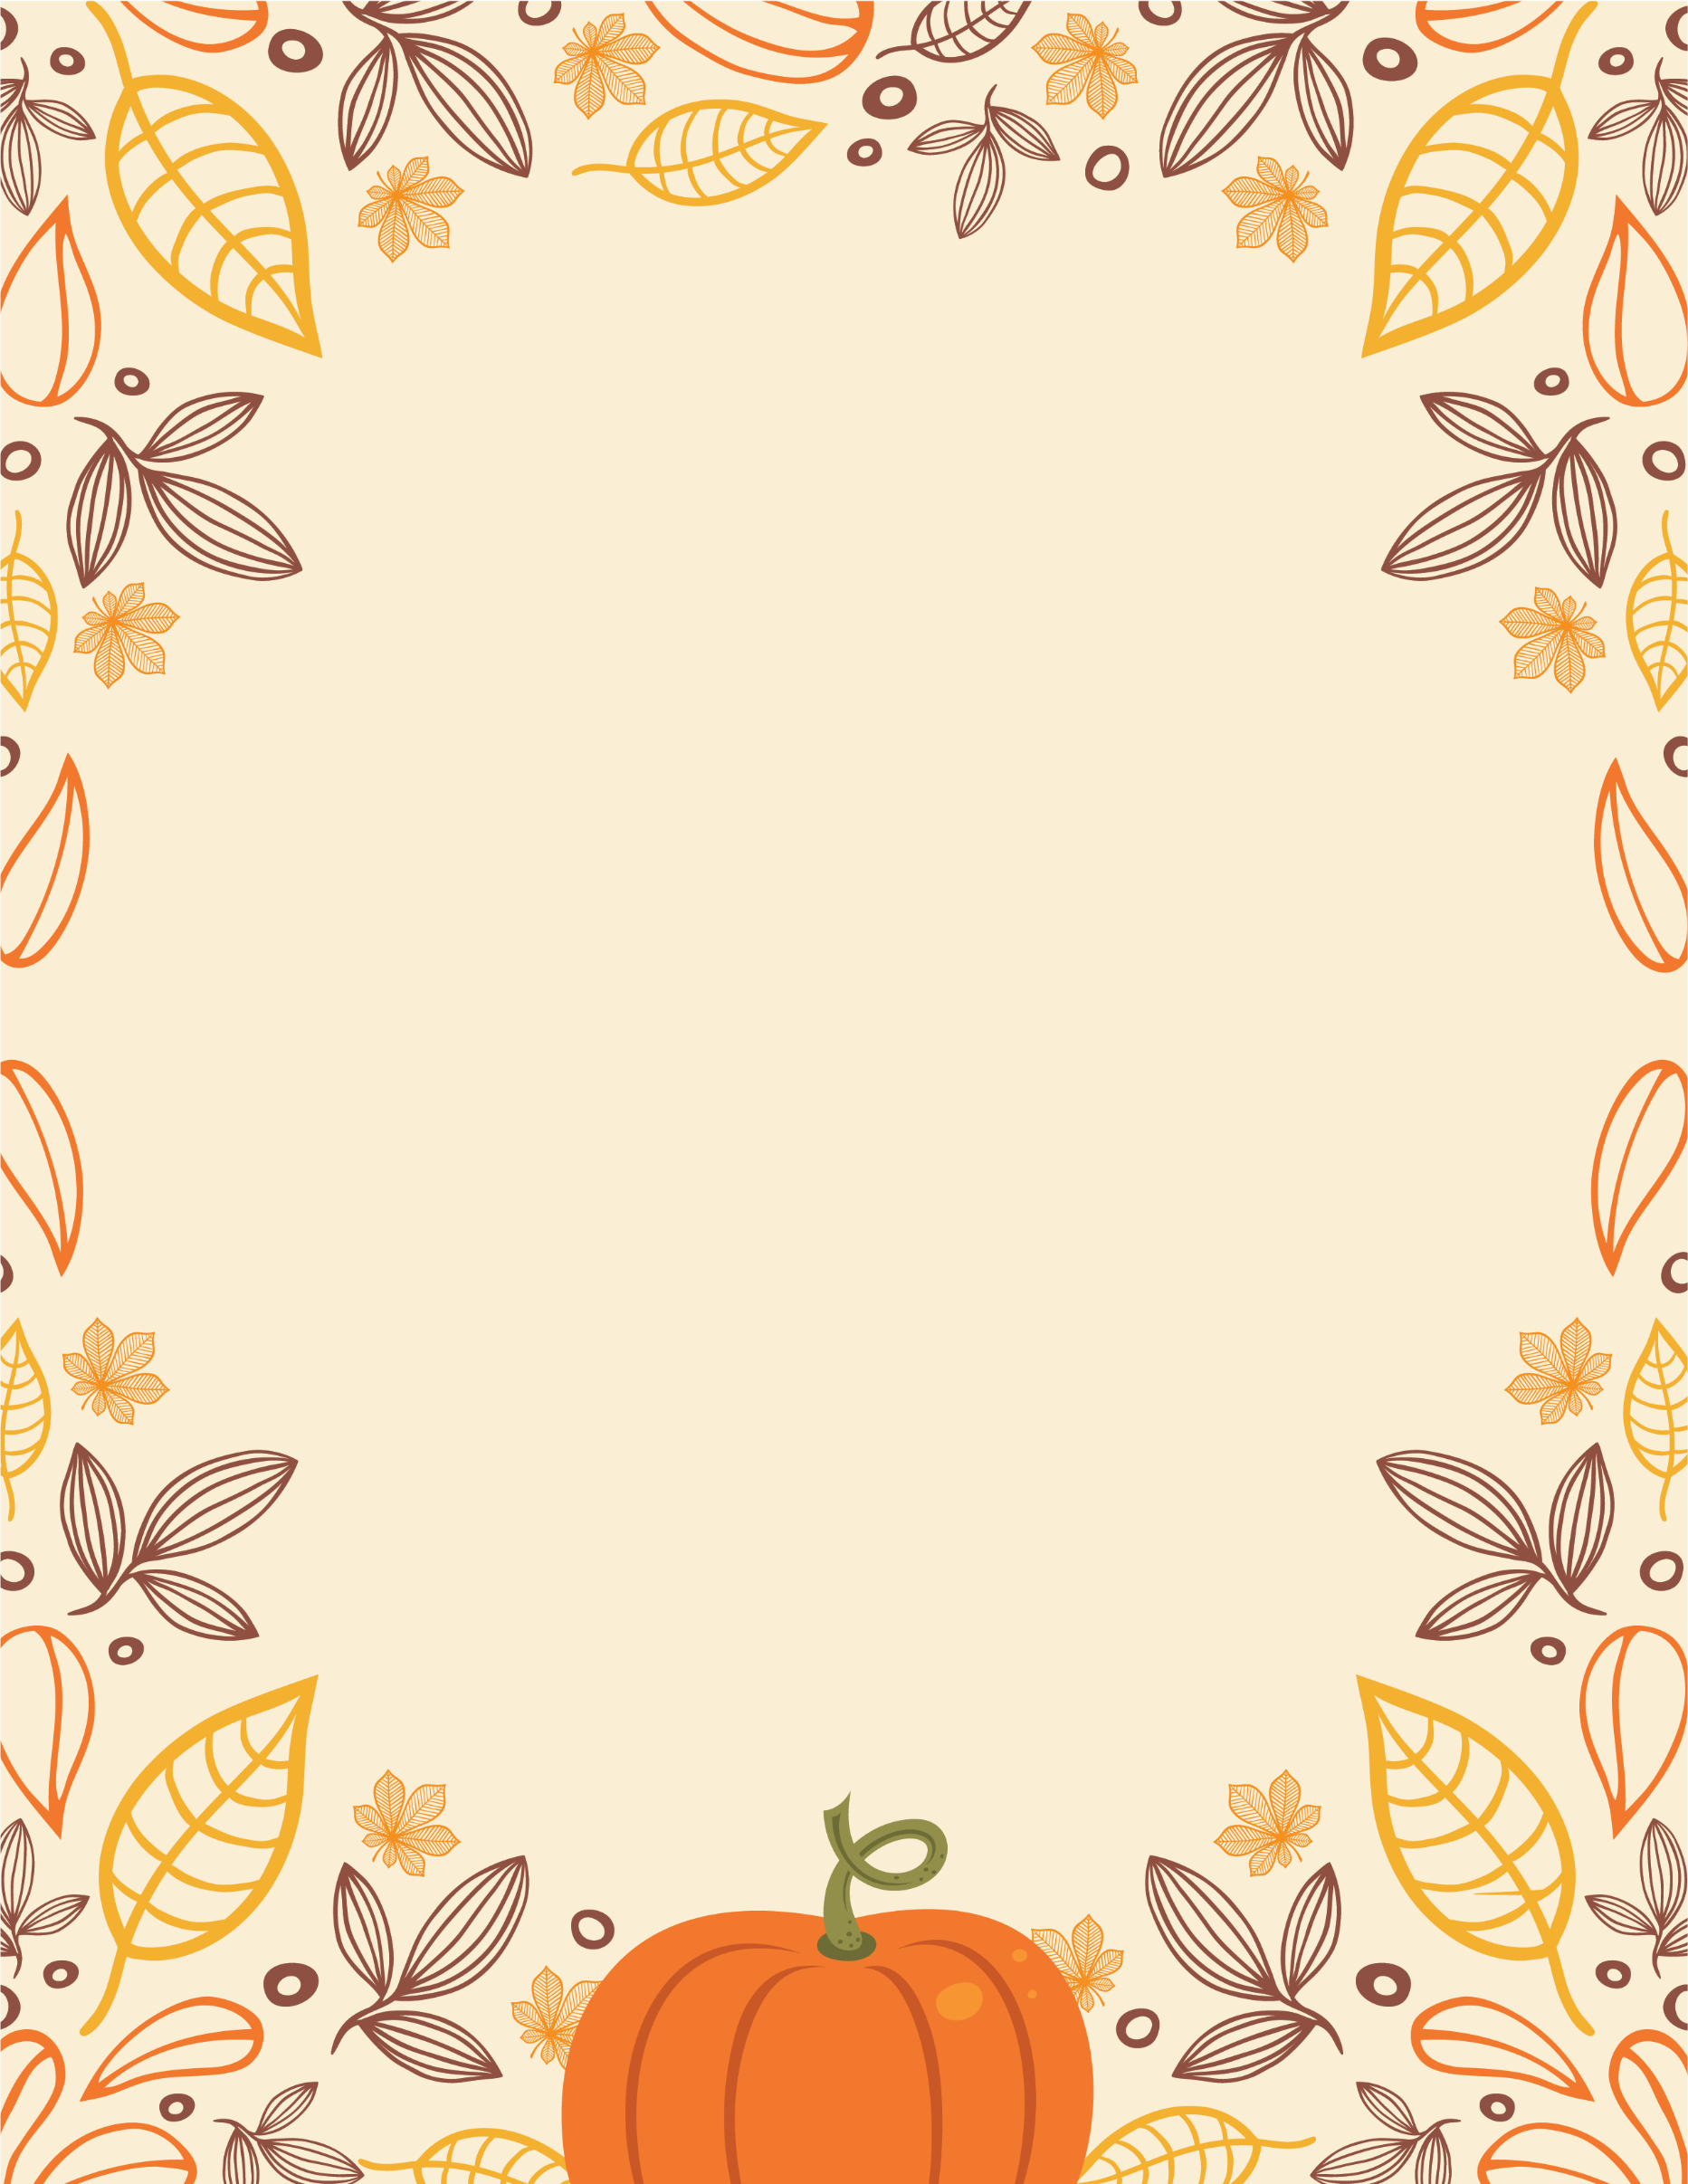
Join us for:
AUTUMN HARVEST
  - CELEBRATION
Saturday September 27th 2pm
Endon Village Hall
Hymns, readings, singing
Led By Rev Debbie & Rev Denise
Refreshments,
Donated produce Auction
Auctioneer Mark Simcock

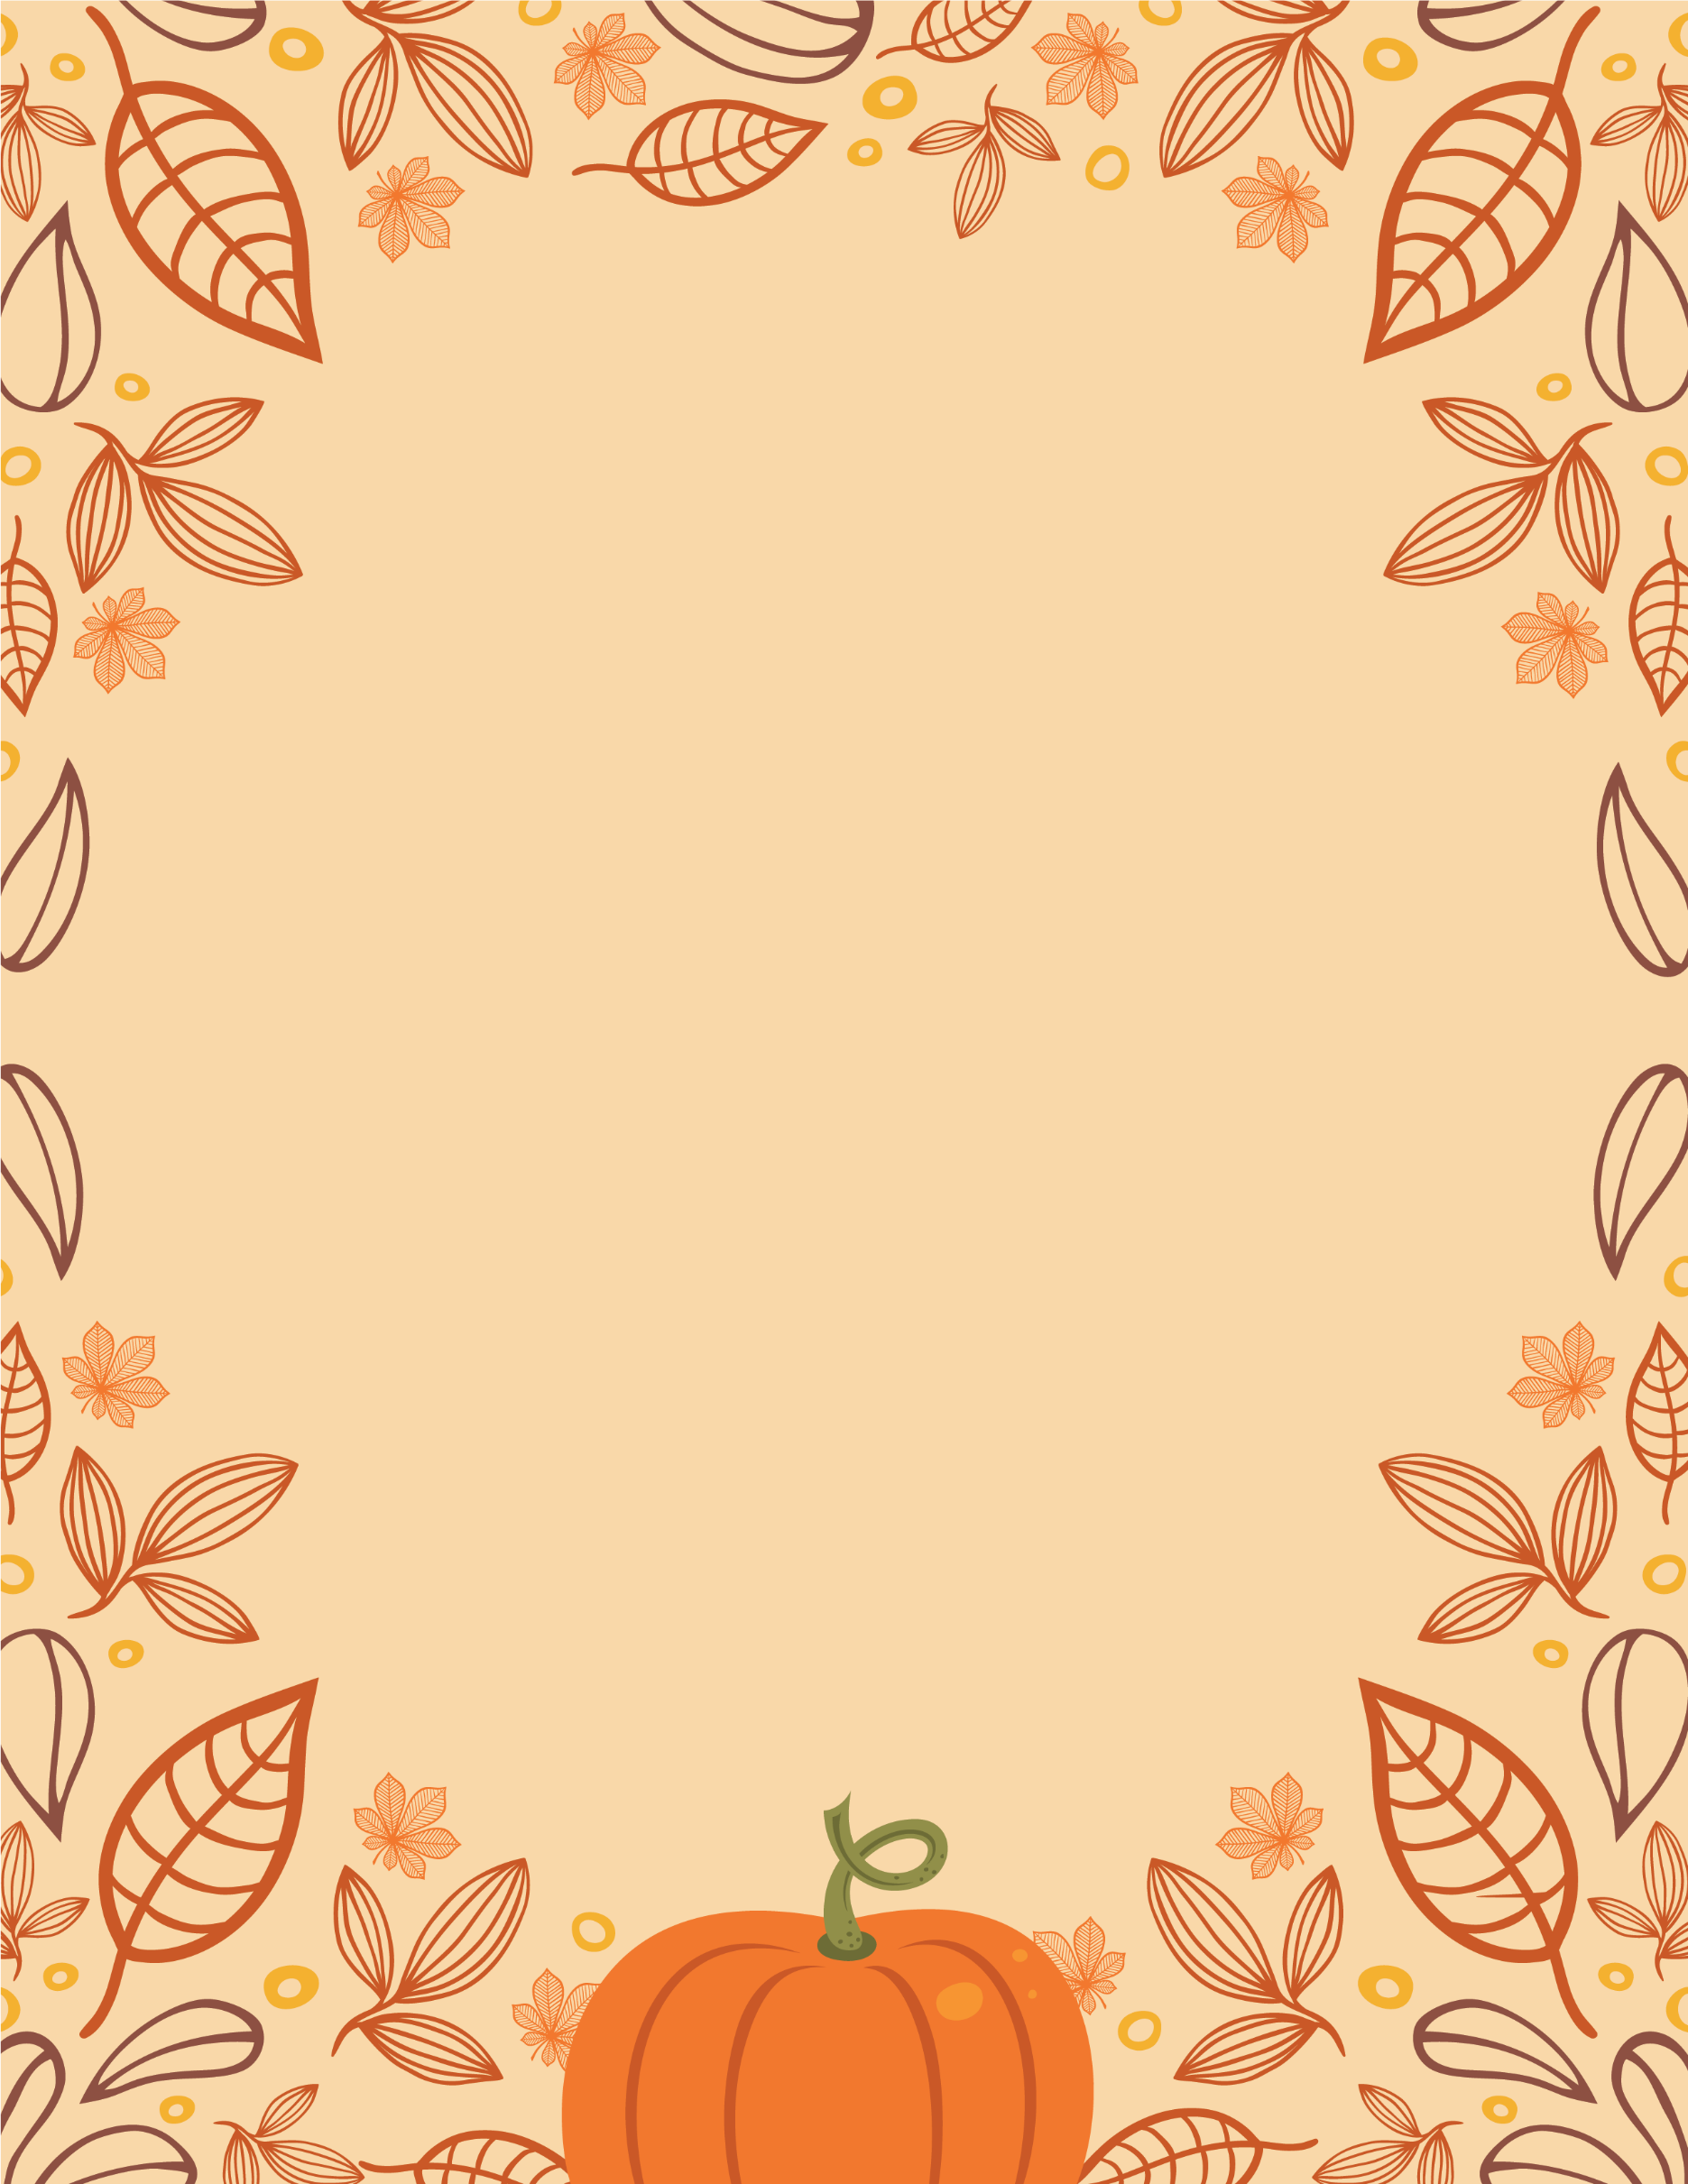
Get ready for a
AUTUMN HARVEST
  - CELEBRATION
November 26, 20xx at 7 PM
Join us in celebrating
the autumn harvest with friends,
food, and more!

